Pune Institute of Computer Technology, Pune

Department of Computer Engineering

A.Y. 2020-21 Semester: I

Database Management System Lab

Name: Aditya Sawant

Roll No: 31302

Batch: K3

ASSIGNMENT 3

TITLE:

Design at least 10 SQL Queries for suitable database application using MYSQL

PROBLEM DEFINITION:

Execute the following queries:

1. Insert at least 10 records in customer table and insert other tables accordingly.

2. Display all customer details with city pune and mumbai and customer first name starting with 'p' or 'h'.

3. lists the number of different customer cities.

4. Give 5% increase in price of the books with publishing year 2015.

5. Delete customer details living in pune.

6. Find the names of authors living in India or Australia .

7. Find the publishers who are established in year 2015 as well as in 2016

8. Find the book having maximum price and find titles of book having price between 300 and 400.

9. Display all titles of books with price and published year in decreasing order of publishing year.

10. Display title , author_no and publisher_no of all books published in 2000,2004,2006.

OBJECTIVE:

To study design and implementation of atleast 10 MYSQL Queries for suitable database application

OUTCOME:

We will be able to understand and implement MYSQL Queries for suitable database application

HARDWARE REQUIREMENTS:

* MONITOR
* KEYBOARD
* 2GB RAM
* 2.4GHz I5 PROCESSOR

SOFTWARE REQUIREMENTS:

* DATABASE-MYSQL
* OS-FEDORA 20

Theory:

Data-Types of Attributes

MYSQL Numeric Data-Types

* TINYINT-A very small integer
* [SMALLINT](https://www.mysqltutorial.org/mysql-int/)-A small integer
* [MEDIUMINT](https://www.mysqltutorial.org/mysql-int/)-A medium-sized integer
* [INT](https://www.mysqltutorial.org/mysql-int/)- A standard integer
* [BIGINT](https://www.mysqltutorial.org/mysql-int/)-A large integer
* [DECIMAL](https://www.mysqltutorial.org/mysql-decimal/)-A fixed-point number
* FLOAT-A single-precision floating point number
* DOUBLE-A double-precision floating point number
* [BIT](https://www.mysqltutorial.org/mysql-bit/)-A bit field

MYSQL String Data-Types

## CHAR-A fixed-length nonbinary (character) string

## VARCHAR- A variable-length non-binary string

* BINARY- A fixed-length binary string
* VARBINARY- A variable-length binary string
* TINYBLOB- A very small BLOB (binary large object)
* BLOB- A small BLOB
* MEDIUMBLOB- A medium-sized BLOB
* LONGBLOB- A large BLOB
* TINYTEXT- A very small non-binary string
* TEXT- A small non-binary string
* [MEDIUMTEXT](https://www.mysqltutorial.org/mysql-text/)- A medium-sized non-binary string
* [LONGTEXT](https://www.mysqltutorial.org/mysql-text/)- A large non-binary string
* [ENUM](https://www.mysqltutorial.org/mysql-enum/)- An enumeration; each column value may be assigned one enumeration member
* SET- A set; each column value may be assigned zero or more SET members

## MYSQL Date and Time Data-Types

* [DATE](https://www.mysqltutorial.org/mysql-date/)- A date value in YYYY-MM-DD format
* [TIME](https://www.mysqltutorial.org/mysql-time/)- A time value in hh:mm:ss format
* [DATETIME](https://www.mysqltutorial.org/mysql-datetime/)- A date and time value in YYYY-MM-DD hh:mm:ss format
* [TIMESTAMP](https://www.mysqltutorial.org/mysql-timestamp.aspx)- A timestamp value in YYYY-MM-DD hh:mm:ss format
* YEAR- A year value in YYYY or YY format

Database Languages:

DDL(Data Definition Language) :- DDL or Data Definition Language actually consists of the SQL commands that can be used to define the database schema. It simply deals with descriptions of the database schema and is used to create and modify the structure of database objects in the database.

**Examples of DDL Commands:**

* [CREATE](https://www.geeksforgeeks.org/sql-create/) – is used to create the database or its objects (like table, index, function, views, store procedure and triggers).
* [DROP](https://www.geeksforgeeks.org/sql-drop-truncate/) – is used to delete objects from the database.
* [ALTER](https://www.geeksforgeeks.org/sql-alter-add-drop-modify/)-is used to alter the structure of the database.
* [TRUNCATE](https://www.geeksforgeeks.org/sql-drop-truncate/)–is used to remove all records from a table, including all spaces allocated for the records are removed.
* [COMMENT](https://www.geeksforgeeks.org/sql-comments/) –is used to add comments to the data dictionary.
* [RENAME](https://www.geeksforgeeks.org/sql-alter-rename/)–is used to rename an object existing in the database.

**DQL (Data Query Language) :**- DML statements are used for performing queries on the data within schema objects. The purpose of DQL Command is to get some schema relation based on the query passed to it.

**Example of DQL Commands:**

* [SELECT](https://www.geeksforgeeks.org/sql-select-clause/) – is used to retrieve data from the database.

DML(Data Manipulation Language) :- The SQL commands that deals with the manipulation of data present in the database belong to DML or Data Manipulation Language and this includes most of the SQL statements.

**Examples of DML Commands:**

* [INSERT](https://www.geeksforgeeks.org/sql-insert-statement/) – is used to insert data into a table.
* [UPDATE](https://www.geeksforgeeks.org/sql-update-statement/) – is used to update existing data within a table.
* [DELETE](https://www.geeksforgeeks.org/sql-delete-statement/) – is used to delete records from a database table.

DCL(Data Control Language) :- DCL includes commands such as GRANT and REVOKE which mainly deals with the rights, permissions and other controls of the database system.

**Examples of DCL Commands:**

* GRANT-gives user’s access privileges to database.
* REVOKE-withdraw user’s access privileges given by using the GRANT command.

TCL(transaction Control Language) :-TCL commands deals with the [transaction within the database](https://www.geeksforgeeks.org/sql-transactions/).

**Examples of TCL Commands: -**

* COMMIT– commits a Transaction.
* [ROLLBACK](https://www.geeksforgeeks.org/sql-transactions/)– rollbacks a transaction in case of any error occurs.
* SAVEPOINT–sets a save point within a transaction.
* SET TRANSACTION–specify characteristics for the transaction.

MYSQL -SELECT QUERY:

The MYSQL SELECT statement is used to fetch the data from a database table which returns this data in the form of a result table. These result tables are called result-sets.

SYNTAX-

SELECT column1, column2, columnN FROM table_name;

MYSQL -WHERE CLAUSE:

The MYSQL WHERE clause is used to specify a condition while fetching the data from a single table or by joining with multiple tables. If the given condition is satisfied, then only it returns a specific value from the table. You should use the WHERE clause to filter the records and fetching only the necessary records.

SYNTAX-

SELECT column1, column2, …..columnN FROM table_name WHERE [condition];

MYSQL - AND and OR Conjunctive Operators:

The AND operator allows the existence of multiple conditions in an MYSQL statement's WHERE clause.

SYNTAX-

SELECT column1, column2, …..columnN FROM table_name WHERE [condition1] AND [condition2]...AND [conditionN];

The OR operator is used to combine multiple conditions in an SQL statement's WHERE clause.

SYNTAX-

SELECT column1, column2, ….. columnN FROM table_name WHERE [condition1] OR [condition2]...OR [conditionN];

MYSQL - UPDATE Query:

The MYSQL UPDATE Query is used to modify the existing records in a table. You can use the WHERE clause with the UPDATE query to update the selected rows, otherwise all the rows would be affected.

SYNTAX-

UPDATE table_name SET column1 = value1, column2 = value2...., columnN = valueN WHERE [condition];

MYSQL - DELETE Query:

The MYSQL DELETE Query is used to delete the existing records from a table. You can use the WHERE clause with a DELETE query to delete the selected rows, otherwise all the records would be deleted.

SYNTAX-

DELETE FROM table_name WHERE [condition];

MYSQL - LIKE Clause:

The MYSQL LIKE clause is used to compare a value to similar values using wildcard operators. There are two wildcards used in conjunction with the LIKE operator.

* The percent sign (%)
* The underscore (_)

The percent sign represents zero, one or multiple characters. The underscore represents a single number or character. These symbols can be used in combinations.

SYNTAX-

SELECT * FROM table_name WHERE column LIKE '%XXXX%';

SELECT * FROM table_name WHERE column LIKE '_XXXX_';

MYSQL - Distinct Keyword:

The SQL DISTINCT keyword is used in conjunction with the SELECT statement to eliminate all the duplicate records and fetching only unique records.

SYNTAX-

SELECT DISTINCT column1, column2,.....columnN FROM table_name WHERE [condition];

MYSQL AGGREGATE FUNCTIONS

MYSQL aggregation function is used to perform the calculations on multiple rows of a single column of a table. It returns a single value. It is also used to summarize the data.

COUNT FUNCTION - COUNT function is used to Count the number of rows in a database table. It can work on both numeric and non-numeric data types.

SYNTAX-

COUNT(*)

COUNT( [ALL|DISTINCT] expression )

SUM FUNCTION - Sum function is used to calculate the sum of all selected columns. It works on numeric fields only.

SYNTAX-

SUM()

SUM( [ALL|DISTINCT] expression )

AVG FUNCTION- The AVG function is used to calculate the average value of the numeric type. AVG function returns the average of all non-Null values.

SYNTAX-

AVG()

AVG( [ALL|DISTINCT] expression )

MAX FUNCTION- MAX function is used to find the maximum value of a certain column. This function determines the largest value of all selected values of a column.

SYNTAX-

MAX()

MAX( [ALL|DISTINCT] expression )

MIN FUNCTION- MIN function is used to find the minimum value of a certain column. This function determines the smallest value of all selected values of a column.

SYNTAX-

MIN()

MIN( [ALL|DISTINCT] expression )

Insert at least 10 records in customer table and insert other tables accordingly. 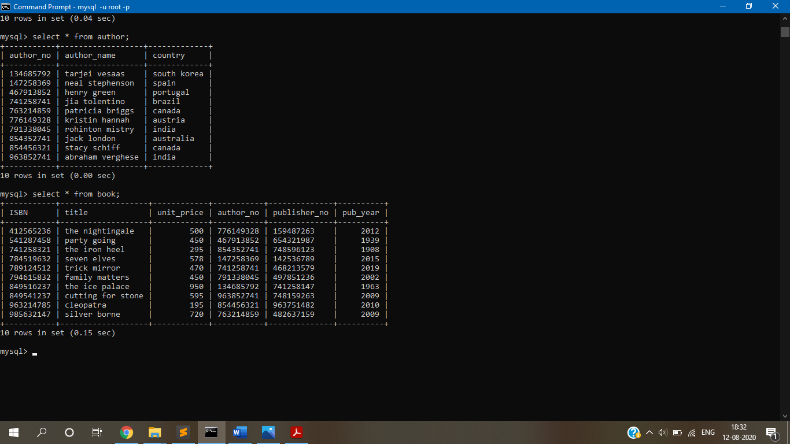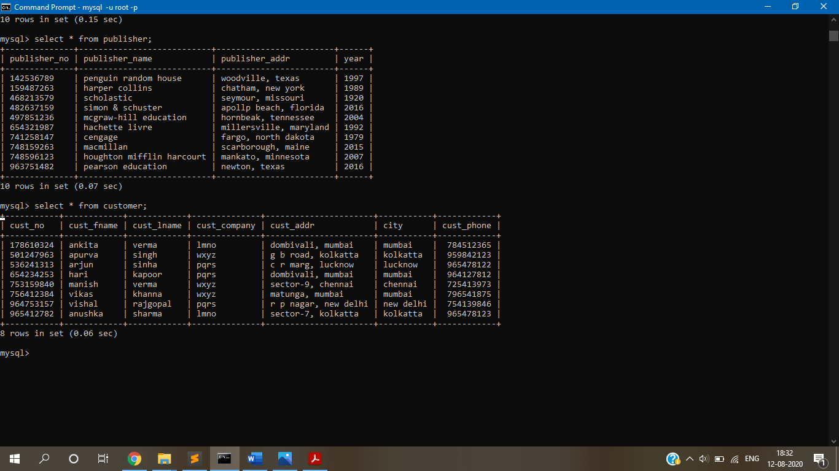

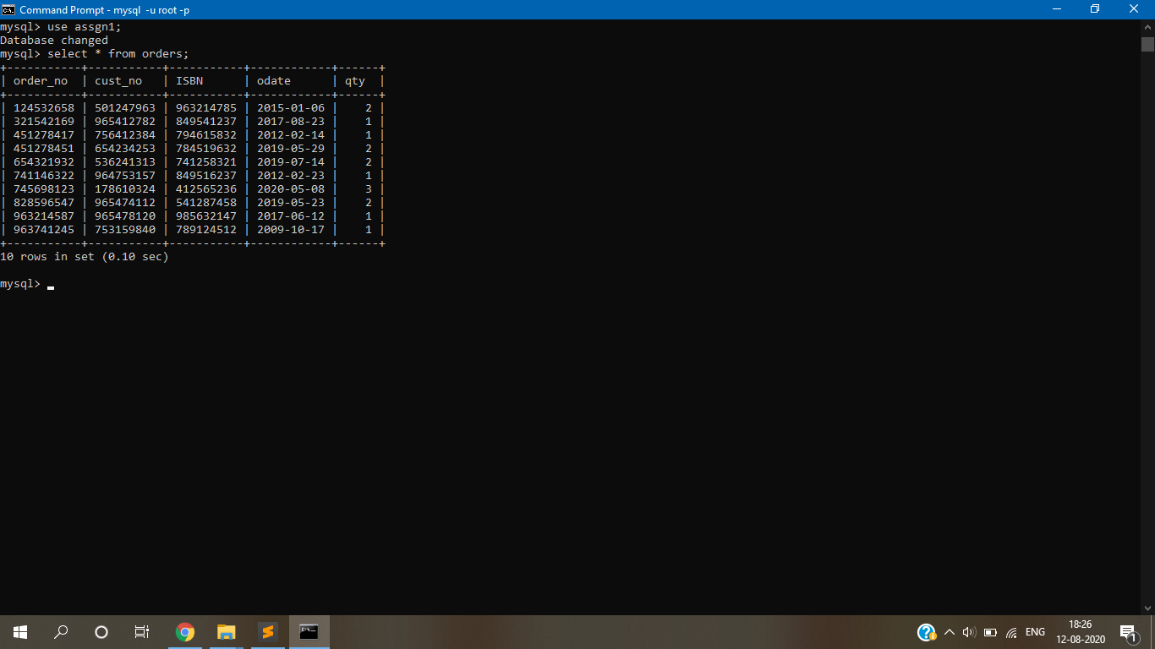

Display all customer details with city pune and mumbai and customer first name starting with 'p' or 'h'.

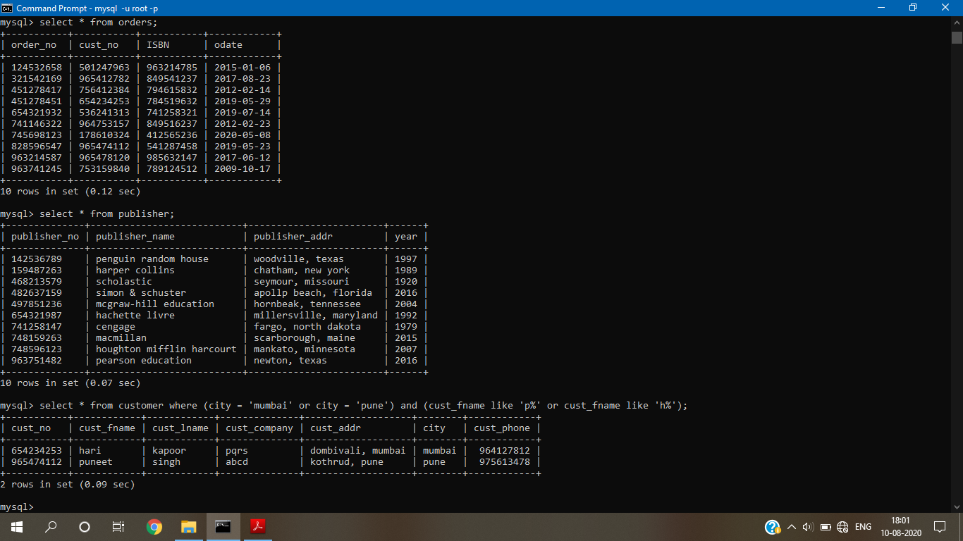

Lists the number of different customer cities.

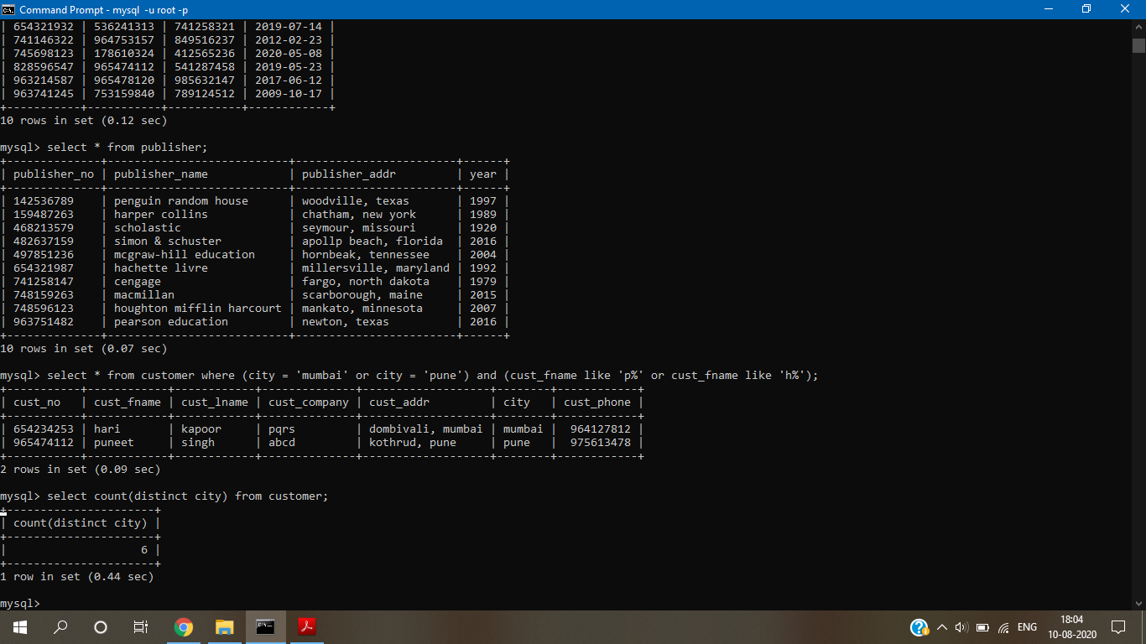

Give 5% increase in price of the books with publishing year 2015.

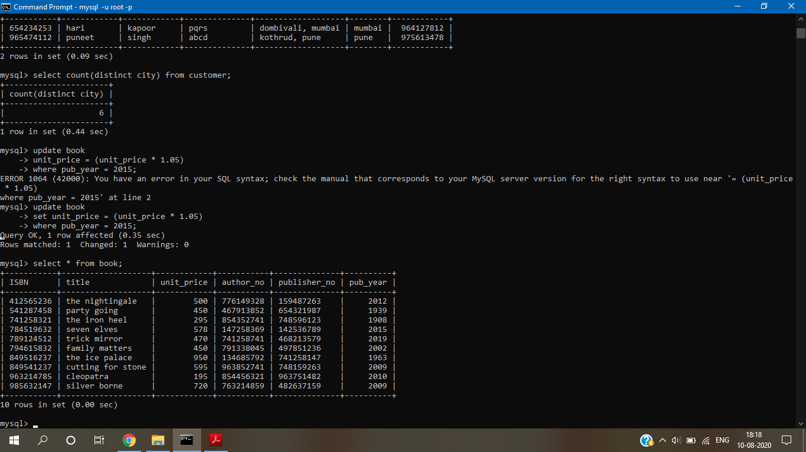

Delete customer details living in pune.

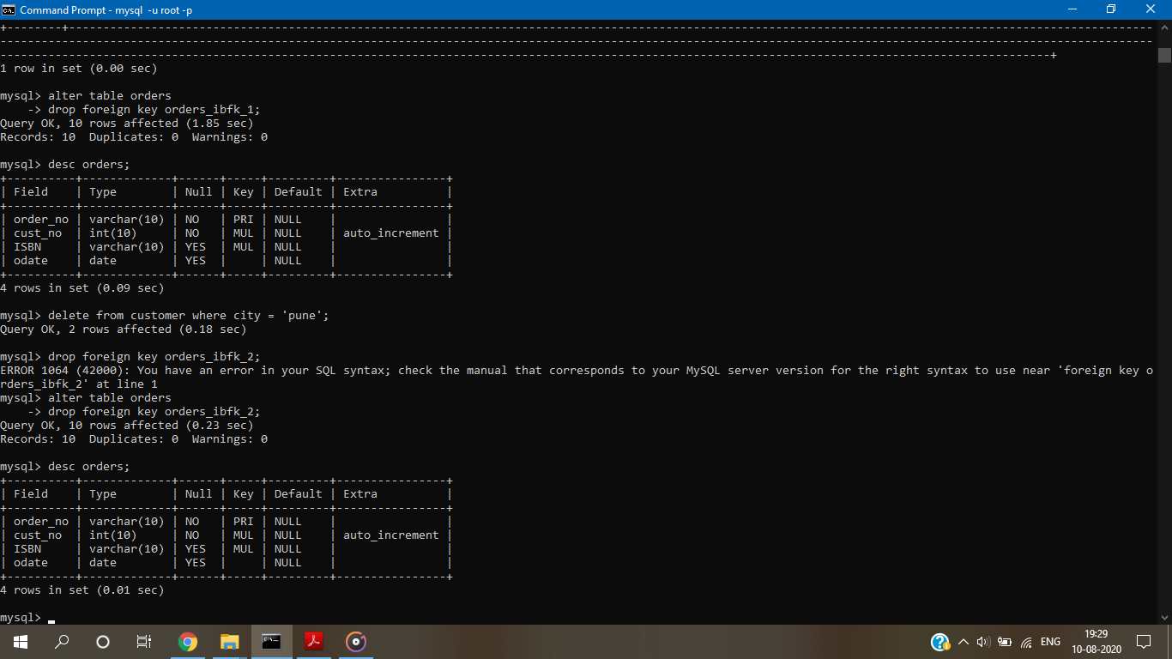

Find the names of authors living in India or Australia .

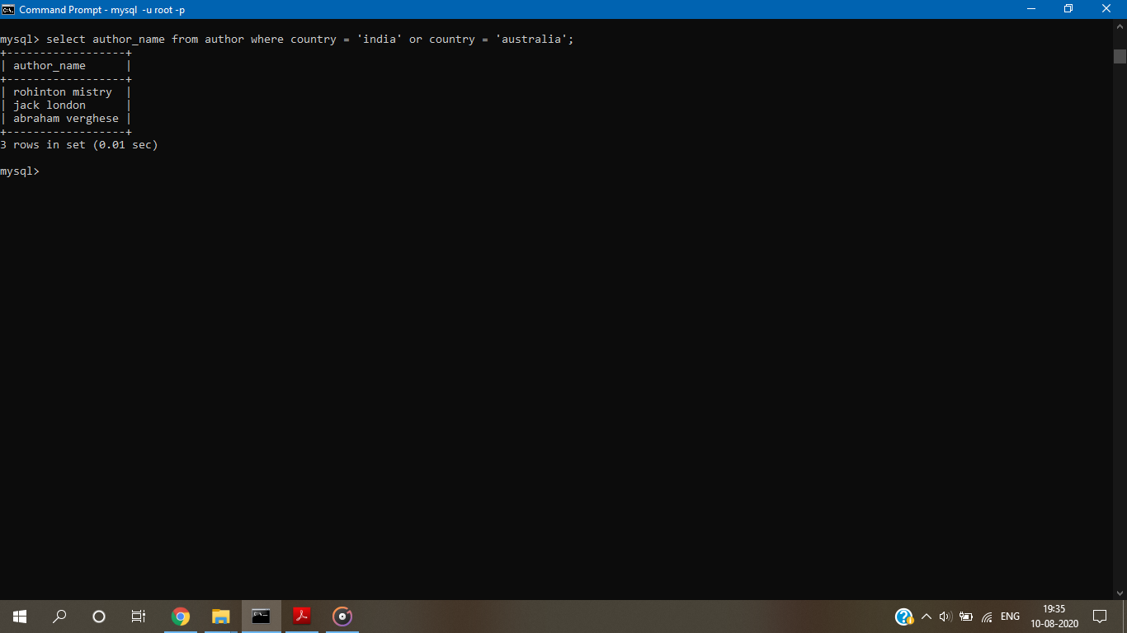

Find the publishers who are established in year 2015 as well as in 2016

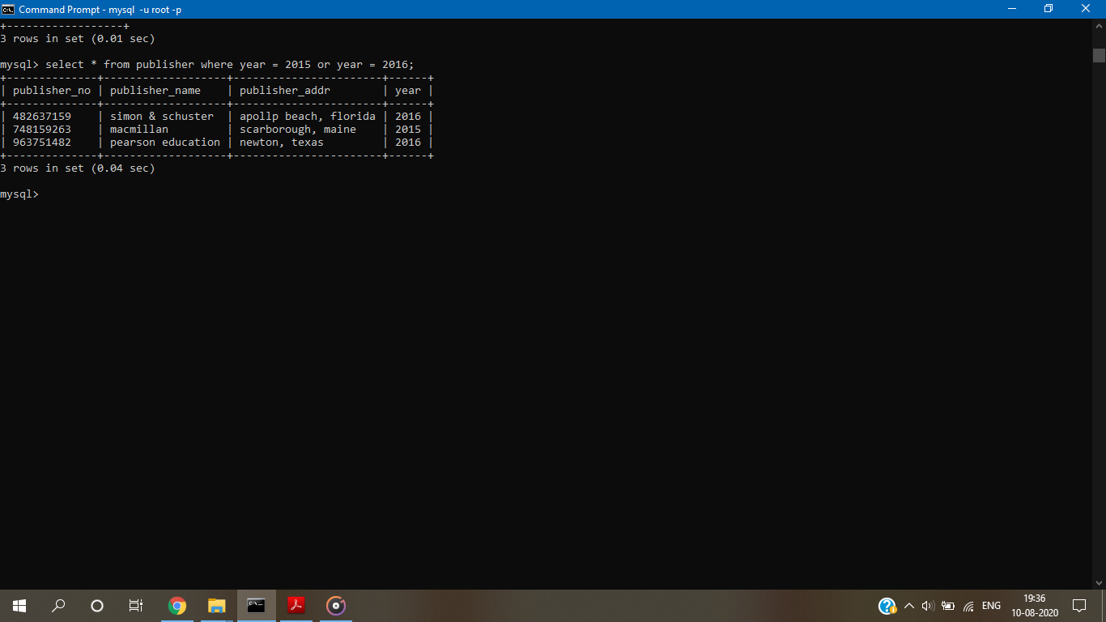

Find the book having maximum price and find titles of book having price between 300 and 400.

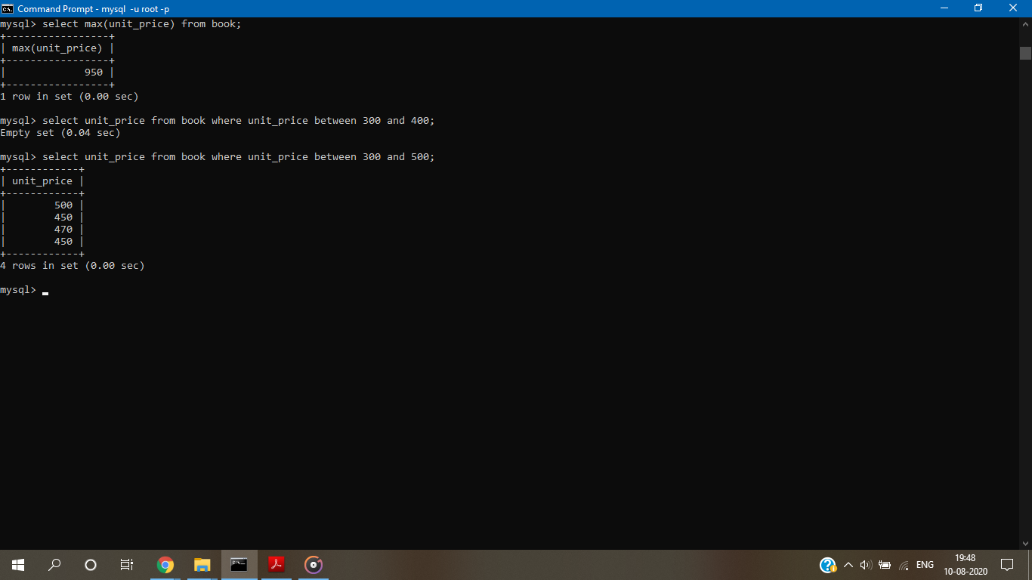

Display all titles of books with price and published year in decreasing order of publishing year.

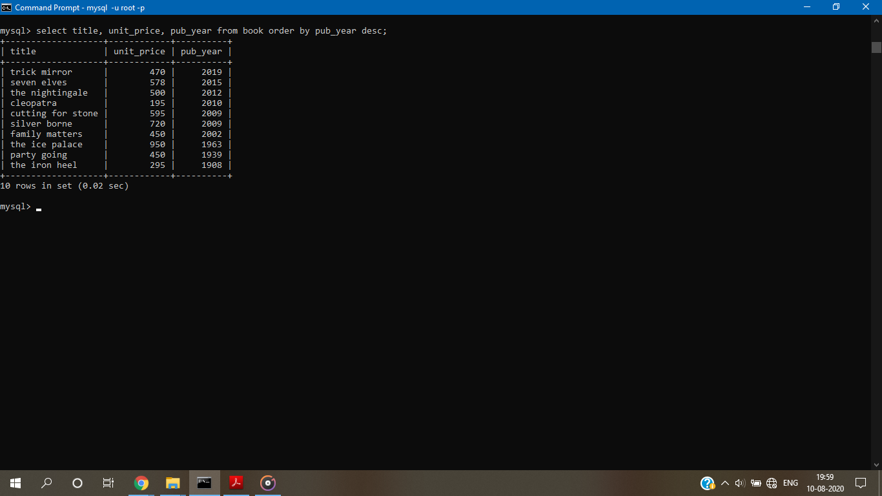

Display title,author_no and publisher_no of all books published in 2000,2004,2006.

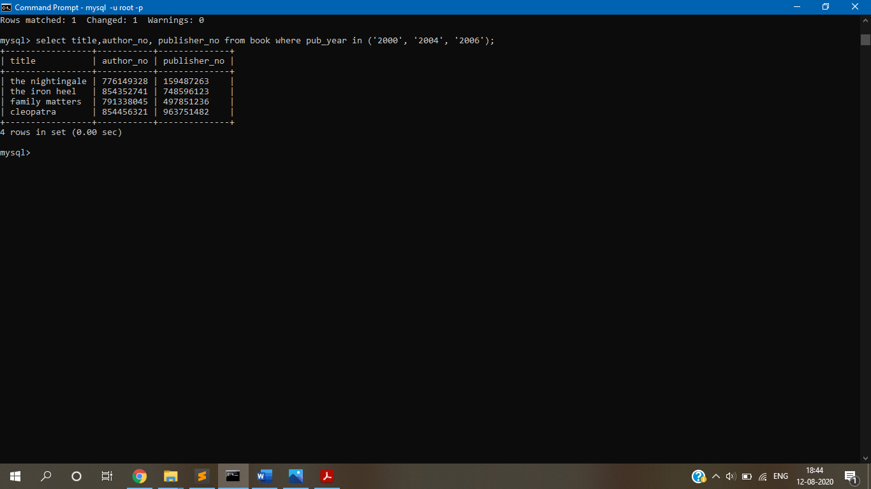

CONCLUSION: -

We successfully understood and implemented all the MYSQL queries for suitable database application.